***Supermarket_Data:***

The growth of supermarkets in most populated cities are increasing and market competitions are also high. The dataset is one of the historical sales of supermarket company which has

recorded in 3 different branches for 3 months data.

Following table provides a summary of the variables and the variable description.

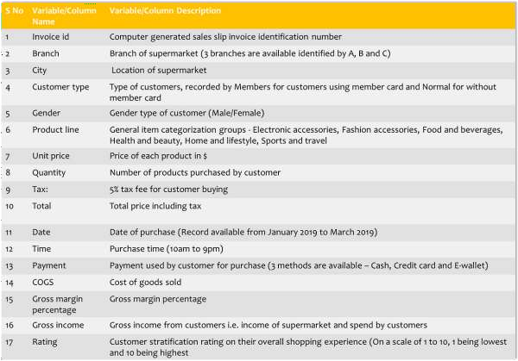

The dataset consists of data from 3 cities ( 3 branches) in Myanmar as given below-

* 1. Branch A (Yangoon)
  2. Branch B (Mandalay)
  3. Branch C (Naypyitaw)

You just joined as a data scientist and you are asked to prepare a PowerPoint presentation to help your manager to understand the branch wise as well as overall health of the supermarket along with what customers think about it. In addition, you have to come out with actionable

recommendations to improve the overall working of the supermarket. Use python to analyse the data